

**Spring 2020**

*Vol. 1 Issue 2*

The Hunter’s Gazette Quarterly Newsletter

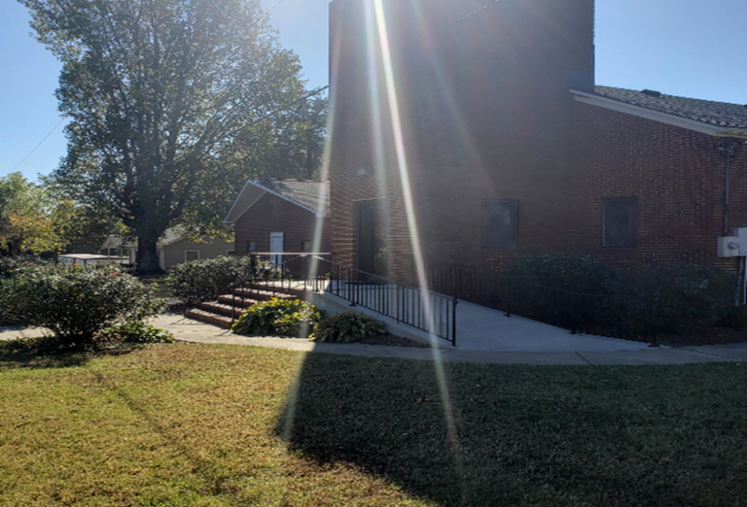

|  |  |
| --- | --- |
| Inside This Issue | |
| 1 | The Presiding Elder’s Corner |
| 1 | A Message from the Pastor and First Lady |
| 2 | Christian Living: Christian Living Principles |
| 2 | Meet the Congregation |
| 2 | Health and Wellness: Spiritual Wellness |
| 2 | Did You Know? |
| 3 | Calendar of Events |
| 3 | Prayer Corner |
| 3 | A Word from the Christian Ed. Director |
| 3 | Christian Word Search |
| 4 | Hunter’s In Action |
| 5 | Bible Crossword |
| 6 | Bible Crossword Answers |
| 7 | Featured Recipe |

The Hunter’s Gazette

*Hunter’s Chapel A.M.E. Church Quarterly Newsletter*

Spring Issue l April 2020

The Presiding Elder’s

Corner

Presiding Elder Anita M. Thompson

Eastern District- WNCC

In the 8th Century B.C., Judah was suffering from weak leadership, and being “faint of heart” when it came to their Praise of the Lord. Isaiah warned Judah for more than 60 years that their backsliding as a nation could only bring sorrow. The people became rebellious and desperately in need of repentance and restoration.

Here we are, just like Judah. God is speaking to the Nations in this time of challenges. God always has a Word for His people. As with Judah, God says, *“Come, my people, enter thou into thy chambers, and shut thy doors about thee: hide thyself as it were for a little moment, until the indignation be overpast.”* (Isaiah 26:20)God says, ‘shelter in place’. Please understand this is only a temporary condition; a moment in the span of time. This indignation we call COVID-19 truly will pass over us. Don't Faint!

James 5:11says, “Behold, we count them happy which endure.”  Joy is Coming!

*Yours in Christ,*

Reverend Anita Maria Thompson

Presiding Elder – WNCC, Eastern District

A message from the

Pastor and First Lady

Reverend Vernon P. Burns

First Lady Sandra Burns

Hunters Chapel A.M.E. Church

My Brothers and Sisters in Christ Jesus,

We give God thanks and we glory in Him even at a time such as this.

We have not in our lifetime had to deal with an unseen enemy like this COVID-19.  COVID-19 has closed colleges, closed schools, and has partially or completely shut down businesses and towns.  Our church buildings have also been closed and we see and hear of hospital rooms being loaded and many people dying.

It is wonderful to know that the church is more than a building.  The church is in the heart of each one of us. Jesus said, “Upon this rock I will build my church and the gates of hell shall not prevail against it”.

We say to you, be encouraged, for the Lord has said, “He will never leave us or forsake us”.  Let us give Him Praise, Glory, and Honor, and have faith in Him.

*Yours in His Service,*

**Reverend & Mrs. Vernon P. Burns**

**Hunter’s Chapel A.M.E. Church**

If you would like to submit a special prayer request, please submit your request to [hunterschapelprayreq@gmail.com](mailto:hunterschapelprayreq@gmail.com).

**Prayer Corner**

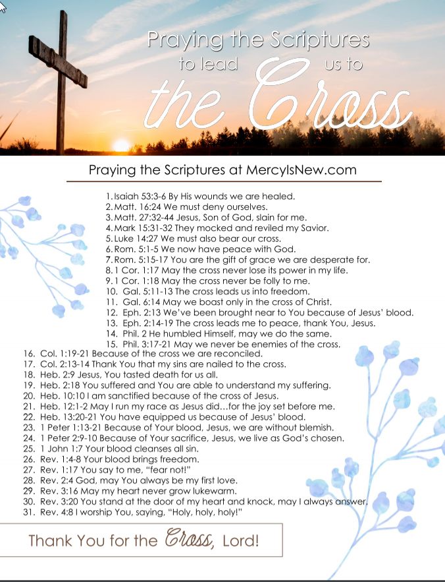





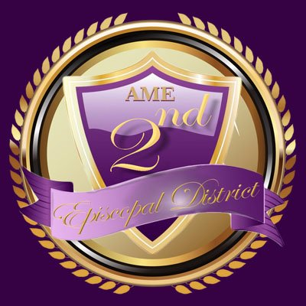



**The Second Episcopal District of the**

**African Methodist Episcopal Church**

*James Levert Davis, Servant Bishop*

*Arelis Beevers Davis, WMS Supervisor*

**Christian Living: Christian Living Principles**

God gave us the Bible to teach us the best way to live and to give us examples of others to learn from. The good and bad examples in the Bible can make what may seem to be abstract principles come to life.

The articles you will be seeing in this “Christian Living” section will help you find and understand the biblical principles for dealing with the challenges of life. They will help you build strong, supportive, loving relationships. They will help you grow in knowledge of God’s way and in acting on that knowledge.

God’s way is the way of love. It’s the way of peace. Biblical principles will help us at home, at church, at school, on the job, in our time management and decision making, in controlling our emotions and in growing in spiritual maturity. By practicing Christian living, we will demonstrate the values that Christ has and the love He shows.

**Meet the Congregation**

Praise the Lord, everybody!!! Sis. Dorothy (Dot) Swann-Brooks has been a life-long member of Hunter’s Chapel A.M.E. Church since she was a youth serving as a member of the Usher Board. Her love for music lead to her singing with a family formed group called The Gospel Melodies which later joined in with the Gospel Choir of the church.

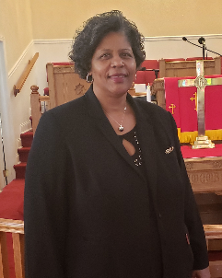

She later assisted with the YPD and the Youth Choir. She also assisted in teaching the youth in Sunday school. Today, Dorothy (Dot) Swann-Brooks is a faithful member of the Youth, Gospel, and Mass Choirs, assists in serving the Kitchen Committee, and is currently the Steward Pro-Tem. In February of 2020, Dorothy Brooks accepted her calling into the ministry. Her Initial Trial Sermon will be preached on April 18, 2020. She has been married for 35 years to Barry Brooks of Hillsborough and together have three children; Travis, Ashley, and J.D and three grandchildren; Jaylen, Shantez, and Ashanti. She is the daughter of Willard Sr. and the late Martha Riley Swann and granddaughter of the late John and Minerva Riley. The motto she lives by is *“If I can help somebody while I’m living, then my living shall not be in vain.”*

**Health and Wellness**

*Spiritual Wellness*

[Spiritual](https://www.goodtherapy.org/learn-about-therapy/issues/spirituality) wellness is related to your [values](https://www.goodtherapy.org/learn-about-therapy/issues/values-clarification) and beliefs that help you find meaning and [purpose](https://www.goodtherapy.org/learn-about-therapy/issues/life-purpose) in your life. Spiritual wellness may come from activities such as volunteering, self-reflection, [meditation](https://www.goodtherapy.org/blog/psychpedia/meditation), prayer, or spending time in nature. Signs of strong spiritual health include having clear values, a sense of self-confidence, and a feeling of inner peace. To improve your spiritual health, it can help to create a quiet space for solitude and contemplation or a place of curiosity and playfulness. Maintaining a playful, curious attitude can help you find experiences that offer [hope](https://www.goodtherapy.org/blog/psychpedia/what-is-hope), purpose, and meaning.

**Did you know?**

**AME Colleges and Universities**

Education has always played an important role in the AME Church. Even before slavery was abolished in 1865, the AME Church began establishing schools to train young African-American men and women. Many of these schools are still active today and include senior colleges Allen University, Wilberforce University, Paul Quinn College, and Edward Waters College; junior college, Shorter College; theological seminaries, Jackson Theological Seminary, Payne Theological Seminary and Turner Theological Seminary.

**The AME Church Today**

The AME Church now has membership in thirty-nine countries on five continents. There are currently twenty-one bishops in active leadership and nine general officers who oversee various departments of the AME Church.

**Calendar of Events**

**Palm Sunday -** April 5th

**Good Friday -** April 10th

**Lent Ends** –April 11th

**Easter Sunday** –April 12th

**Trial Sermon of Sis. Dorothy Brooks** – April 18th

**Women’s Missionary Program** – April 19th

**Pastor Appreciation** – April 26th

**WNCC Annual Conference** – May 5th-9th

**Mother’s Day** – May 10th

**Arm Forces Day** – May 16th

**Women’s Day Program** – May 17th

**Memorial Day** – May 25th

**Vacation Bible School** – June 8th- 12th

**Father’s Day** – June 21st

**A Word from the Christian Ed**. **Director**



*Sis. Shirley Coble-Ray*

Happy New Year! Join us as we celebrate and learn in 2020! Christian Education Calendar 2020

January

Celebrate the Struggle for Justice, Freedom, Equality Learnings from Dr. Martin L. King Jr.

February

Teaching and Celebrating Founders Day. Black Heritage Observance.

March

Teaching and Celebrating Lent/Easter

April

Annual Connectional Ministries in Christian Education Training and Planning Session.

May

Teaching about Worship. Celebration of Mother’s Day

June

Recognition of School Graduates. Church Sunday School Promotion. Celebration of Father’s Day.

July

Vacation Bible School. Episcopal District Leadership Education Events.

August

Teacher Appreciation and Back to School Celebration.  Teaching about Baptism and Communion

September

Observe/Celebrate Christian Education Month. Grandparents Day

October

Celebration of Black Family.  Breast Cancer Awareness

November

Teaching on the Thanksgiving and the importance of Giving. Celebration of our Veterans

December

Teaching and Celebrating Christmas and Celebrating our Seniors.

***Christian Word Search***

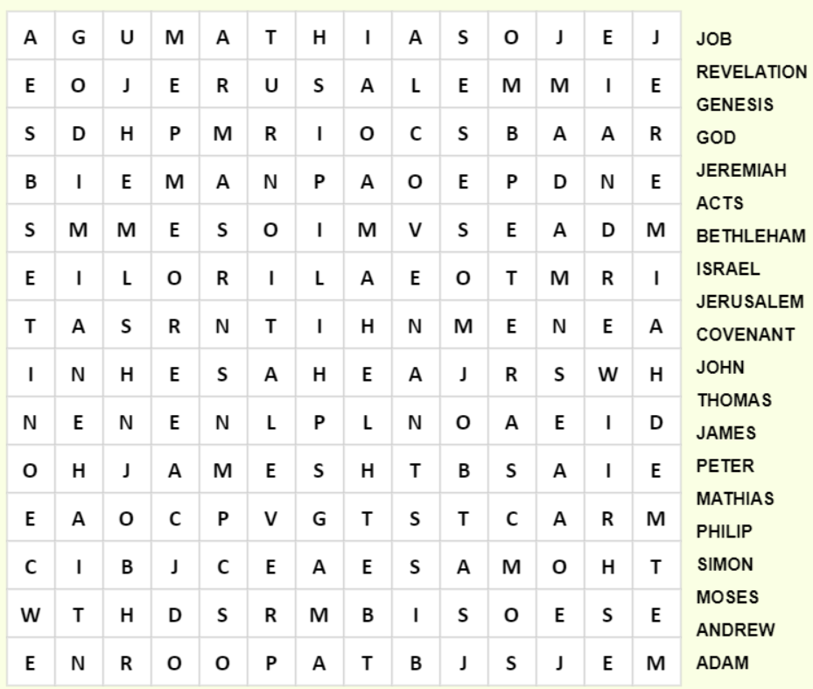

HUNTER’S IN ACTION

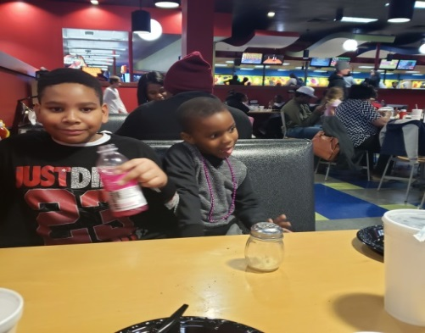

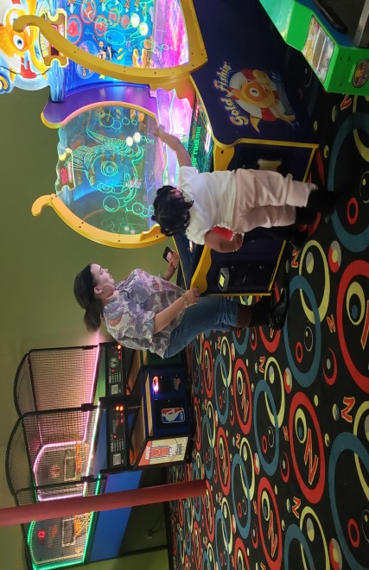





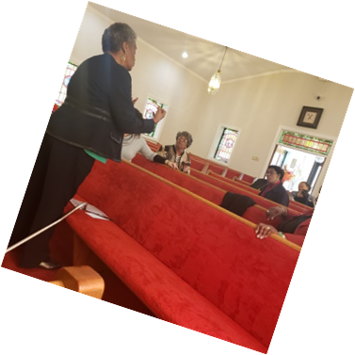

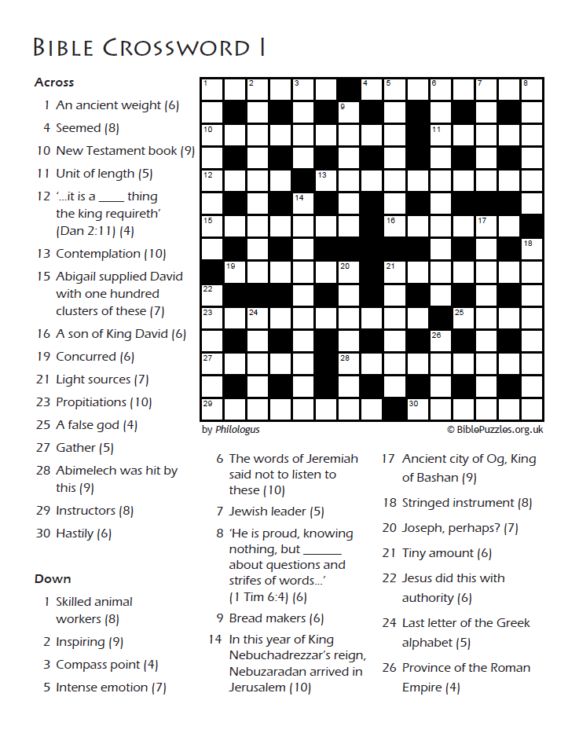

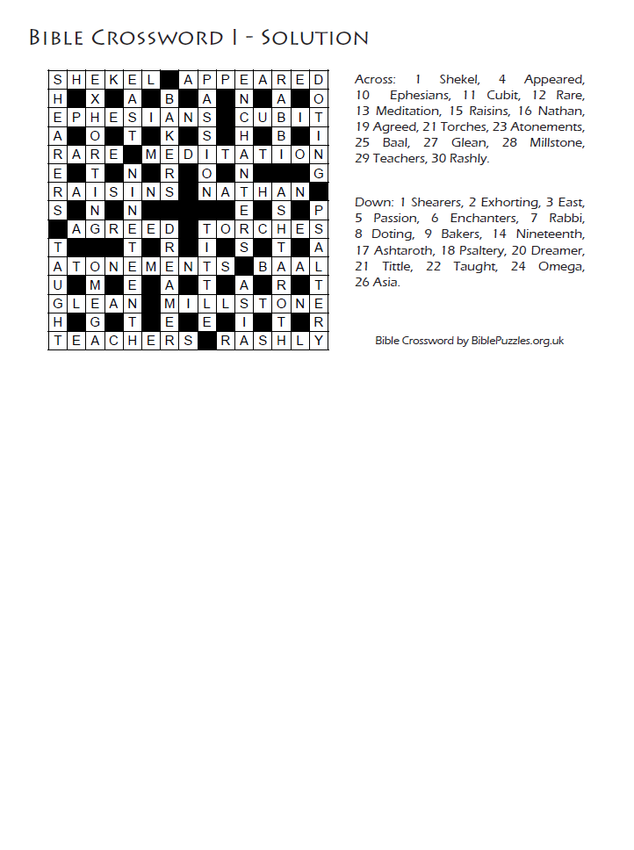

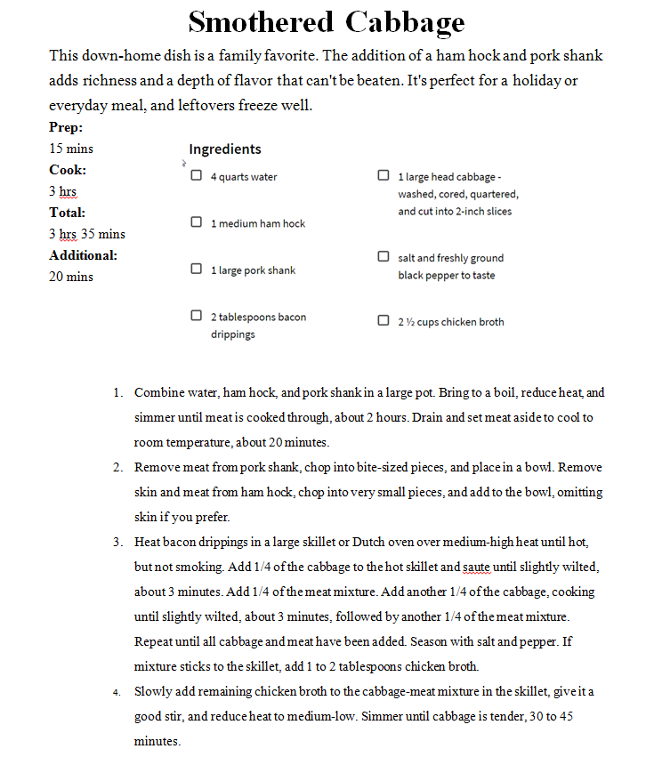**Featured Recipe**